#### My Portfolio Website

#### (Minor Project-II)

A Project Report

Submitted in Partial Fulfillment for the Award of the Degree of Master of Computer Applications (M.C.A)

**2022-2024**

**Submitted By: Vaibhav Goel Guided By: Mr.Nripesh Kumar Nirp**

**University PRN: 2228100742**



**BHARATI VIDYAPEETH DEEMED TO BE UNIVERSITY, PUNE SCHOOL OF DISTANCE EDUCATION, PUNE**

**Academic Study Center - BVIMR, New Delhi**

**An ISO9001:2008 Certified Institute**

**NAAC Accredited Grade “A+” University**



**Student Undertaking**

#### Certificate of Originality

#### I Vaibhav Goel, Master of Computer Applications (M.C.A) 3rd Semester would like to declare that the project report entitled “My Portfolio Website” Submitted to Bharati Vidyapeeth University Pune, School of Distance Education Pune, Academic Study Centre BVIMR New Delhi in partial fulfillment of the requirement for the award of the degree.

#### It is an original work carried out by me under the guidance of “Mr.Nripesh Kumar Nirp”.

#### All respected guides, faculty member and other sources have been properly acknowledged and the report contains no plagiarism.

#### To the best of my knowledge and belief the matter embodied in this project is a genuine work done by me and it has been neither submitted for assessment to the University nor to any other University for the fulfillment of the requirement of the course of study.

**Student Name with Signature**

#### Vaibhav Goel

#### ____________

#### Preface

#### Welcome to Vaibhav Goel's Digital Showcase

#### Greetings, curious minds and kindred spirits! I am Vaibhav Goel, a M.C.A Student with an insatiable passion for Software Developing. Within these digital walls, I'm thrilled to unveil a glimpse into my creative universe.

#### This portfolio is more than a compilation of projects—it's a narrative of my journey through the ever-evolving landscape of career. Each pixel and line of code is a brushstroke, contributing to a canvas that tells the story of my dedication to my career.

#### In this space, you'll find a medley of ideas brought to life, challenges met with enthusiasm, and a celebration of the artistry inherent in technology. Whether you're a fellow enthusiast, a potential collaborator, or a casual explorer, I invite you to traverse these digital corridors and witness the evolution of my craft.

#### This portfolio is not just about showcasing what I've done; it's an invitation to join me on a journey of what can be. So, grab a metaphorical seat, click around, and let's connect. I look forward to the possibility of creating something extraordinary together.

#### Thank you for stepping into my digital realm.

#### Best regards,

#### Vaibhav Goel

#### 2228100742

#### MCA 2nd YEAR SEM III

**Acknowledgement**

***“MY PORTFOLIO WEBSITE”***

Firstly, I would like to extend my sincere thanks to my guide “**Mr.Nripesh Kumar Nirp**”, for his valuable guidance, insightful feedback, and continuous support throughout this project. His expertise and advice have been invaluable in shaping my work and improving its quality.

I would like to express my appreciation to Bharati Vidyapeeth University for providing me with the necessary facilities and resources to carry out this project. Their support has been vital to the progress of this work, and I am grateful for their assistance.

Finally, I would like to thank my family and friends for their unwavering support, encouragement, and understanding throughout this journey. Their motivation and love have kept me going and inspired me to pursue my goals.

Thank you for your contributions and support so far.

#### Vaibhav Goel

#### 2228100742

**MCA 2nd YEAR SEM III**

**_________________**

**Table of Contents**

|  |  |  |
| --- | --- | --- |
| Chapter No. | Chapter Name | Page No. |
| 1 | **Introduction of Software.** | 1 |
| 2 | **Software Analysis.**  **2.1 Software Used.**  **2.2 Hardware Used.** | 2 |
| 3 | **System Design.**  **3.1 System Design.**  **3.2 Screen Design.** | 3-6 |
| 4 | **Testing and Implementation.**  **4.1 Testing.**  **4.2 Implementation.** | 7 |
| 5 | **Source Codes.**  **5.1 CSS Files.**  **5.2 HTML File.** | 8-33 |
| 6 | **Conclusion.** | 34 |

**Chapter-1**

**Introduction of Software**

Now, in every field and every work can be done by computers and machines which can run on hardware and hardware follows the instructions given by the software. Software is now becoming an essential part of our life. For Example- In Schools, offices, colleges and many other places which have a huge number of people or candidates have to record the personal data of an individual, contracts, projects, assignments, attendance, mode of payment, etc.

My Portfolio Website is a website that handles the details, education, experience and projects done by me. This website is a front-end development project which carries out by me in coming days with HTML, CSS & JavaScript.

This website contains all the information and contacts which is sufficient for a viewer just like academic projects, education, about me and many more.

This is also connected to all my social media pages like my account on Facebook, Twitter, Gmail, and LinkedIn.

This website contains the following Tabs in top of the website

* Home
* About
* Education
* Projects
* Experience

**1**

**Chapter-2**

**Software Analysis**

**2.1 Software Used:**

In this we will discuss that by software the following software can be developed and how it can be used.

I can developed the My Portfolio Website with the help of notepad which is used by so many schools , institutes, colleges and Universities for learning and implementing web programming . This software can compile the both text files and web pages source codes by saving the text file with extension “filename.txt” and by saving the web page type file with extension “filename.html”.

This Software can easily run on any computer or laptop which has the web browser software and compile it easily so that one can use this developed software. We can also use the JavaScript and CSS in this Software to run the Developed software and take a précised output after successful compilation of software source code.

**2.2 Hardware Used:**

In this Module we can discuss that what type of hardware configuration is good for running our developed software and how it differs from system to system.

We can run the developed software on any hardware Configuration which is higher than 2007 developed window or iOS. We can compile the following software source code on any operating system which supports web browser and notepad and the operating system which does not supports this then we have to do some changes like directories to compile and successfully run them.

If we cannot change the above changes then this will create a problem due to which errors are came and it is difficult to handle the software for user but developer can apply these changes so that the user cannot by dissatisfied.

**2**

**Chapter-3**

**System Design**

#### 3.1 System Design.

#### In System Design, we can explain that how our website looks and which tabs are there. The following tabs also includes their functioning which we planned for them.

1. HOME- On clicking on HOME tab, user can directed to Home page of my website which contains my name in capital and my current position.
2. ABOUT -On clicking this tab, user can directed to about tab which tells us about the information and history of the mine.
3. EDUCATION- On clicking this tab user can go to the tab where they can find my educational qualifications.
4. PROJECTS – On clicking this tab, user can direct to the projects tab where one can see the academic projects done by me with project report.
5. EXPERIENCE- On clicking this tab, viewer can view the courses that was done by me.

#### 3.2 Screen Design.

Our Main tab is in the top right on website which contains tabs, which was connected to other options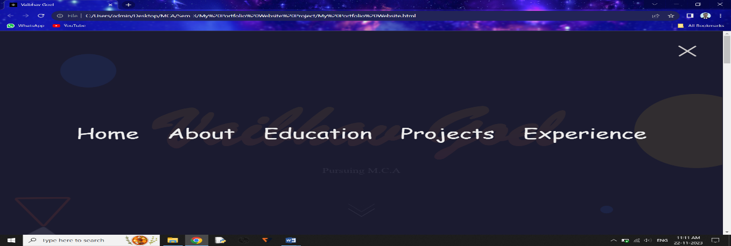

Fig 3.1- Main Tab.

**3**

#### 1. HOME Page.

#### 

#### Fig 3.2- Layout of Home Page.

#### 2. ABOUT Page.

#### 

Fig 3.3- Layout of About Page.

When we click on Checkout My Resume, we can saw my resume as attached and download it and when we click on social media icons like LinkedIn, Github, Facebook and twitter(X) we can saw my social accounts.

**4**

3. EDUCATION Page.

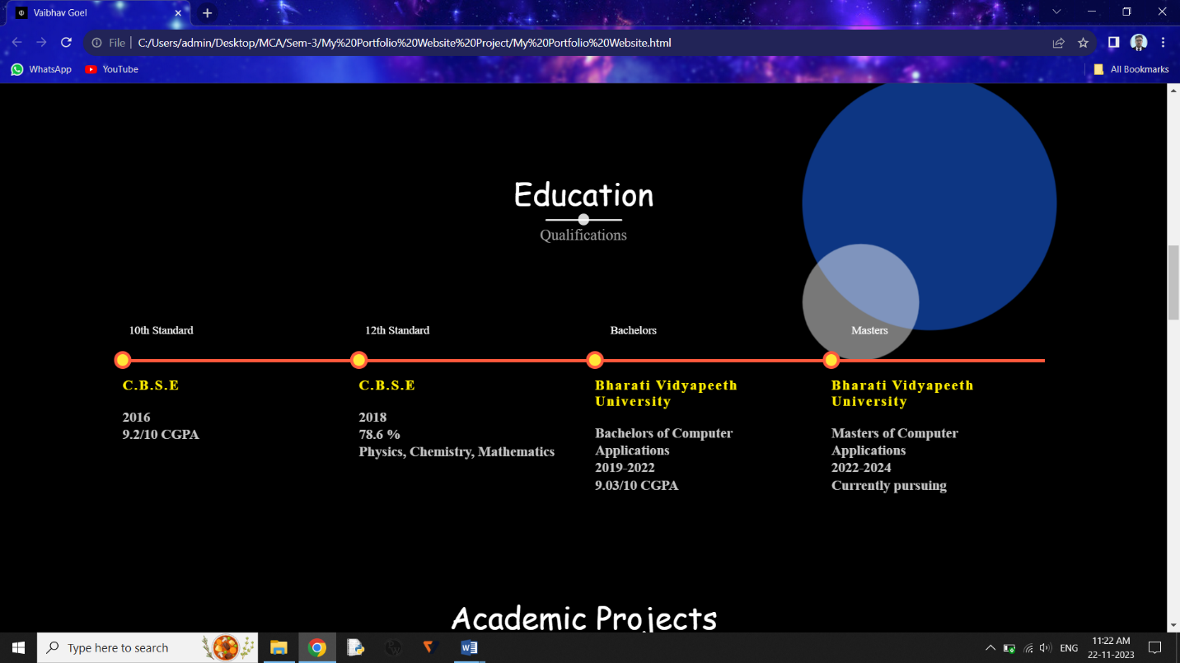

Fig-3.4 Layout of Education Page

4. PROJECTS Page.

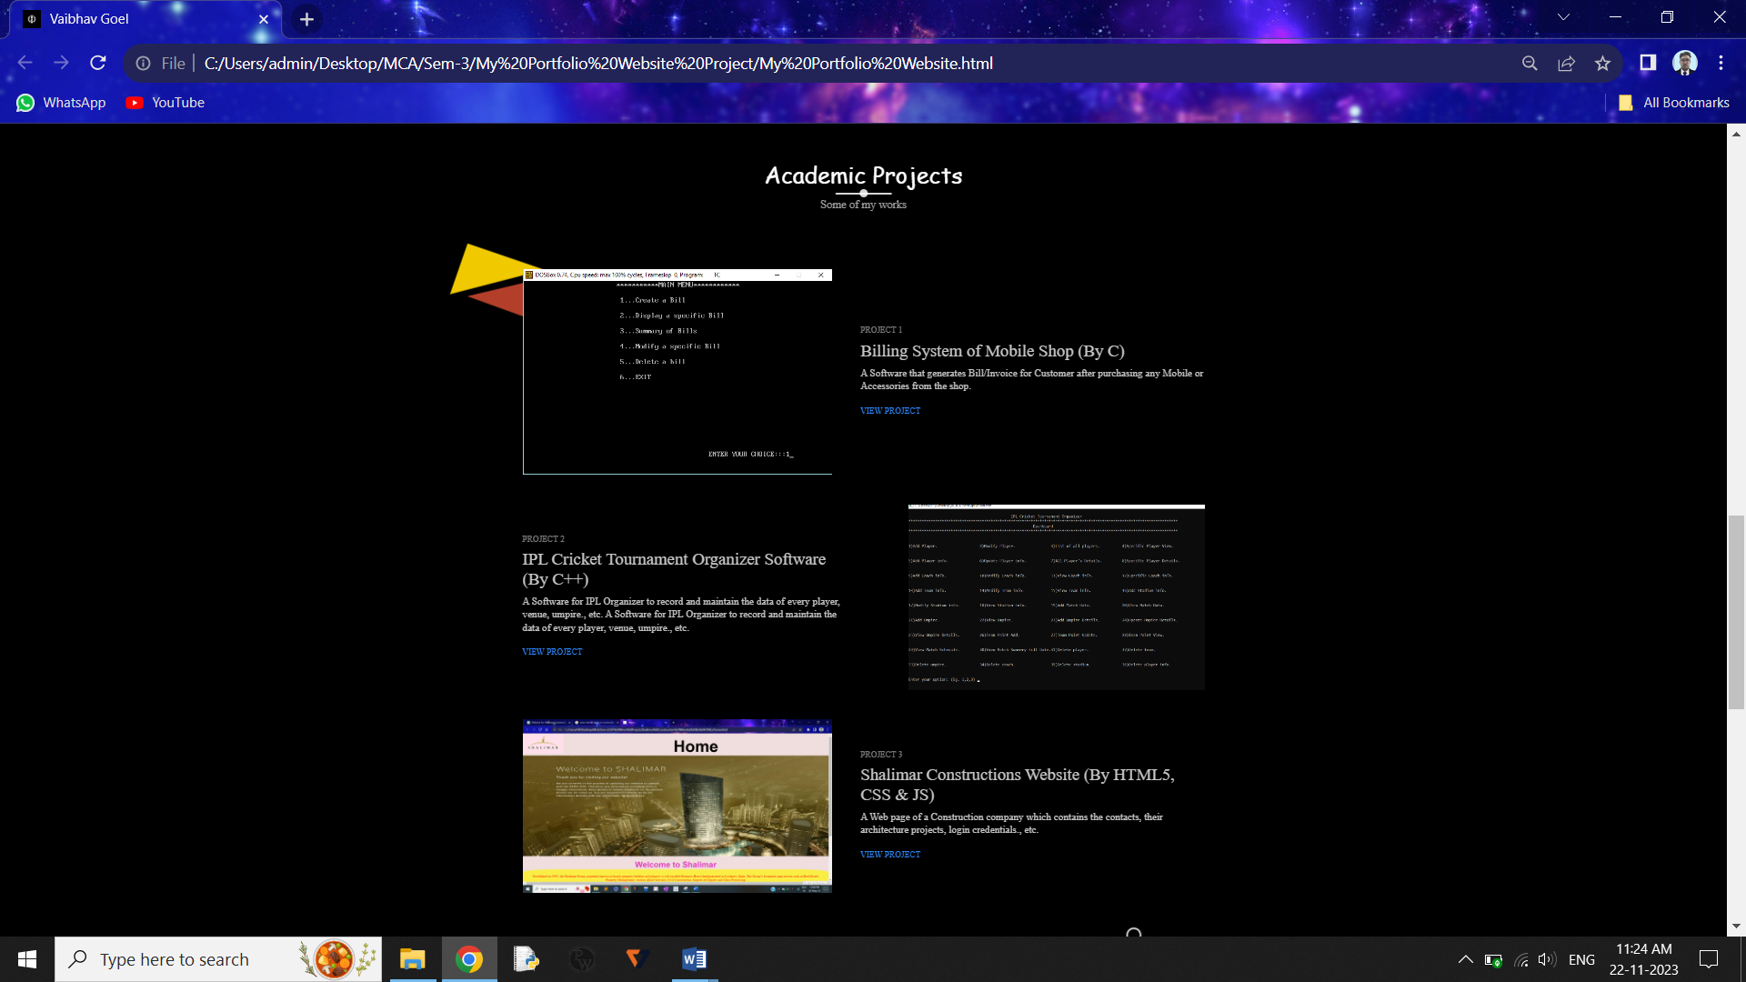

Fig-3.5 Layout of Projects Page

When we click on VIEW PROJECT, we can see the project report of previous academic projects made by me.

**5**

1. EXPERIENCE Page.

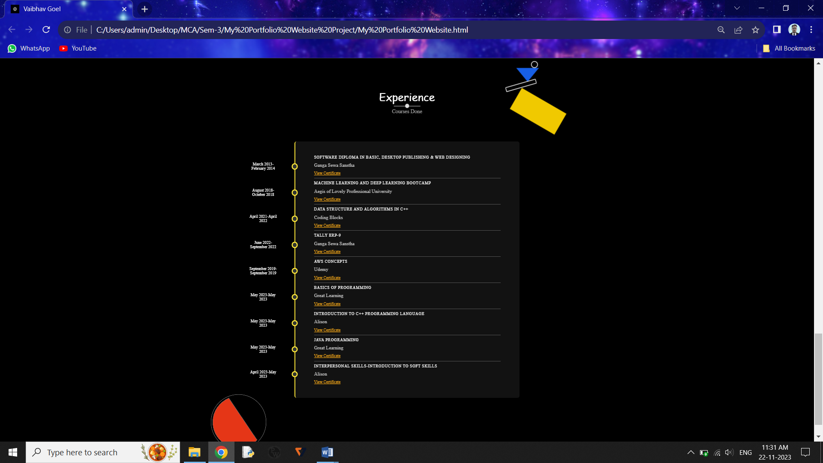

Fig-3.6 Layout of Experience Page

When we click on the View Certificate, we can see the certificate of that particular dourse done by me.

**6**

**Chapter-4**

**Testing and Implementation**

**4.1 Testing.**

Testing is a process in which tester can check all the conditions which can be used in software and decides whether it will pass the test or not.

**4.2 Implementation.**

During Testing tester can implement all the suitable cases by which error can be generated

And check whether the software can able to access these situations or not.

Testing and Implementation can be done by developer at many stages and so many types of cases are implemented to test the software, so that one can identify and rectify the errors or mistakes in Software. For Example- We can test the software by giving the wrong option which is not mention in main menu and can implement this that what will happen.

My portfolio also contains the social media tabs which is used to connect to social accounts

* Facebook page,
* twitter account,
* Github, and
* LinkedIn.

To saw my social media accounts to explore about me.

If we click on the Facebook page then firstly it wants to login with your id to saw my account.

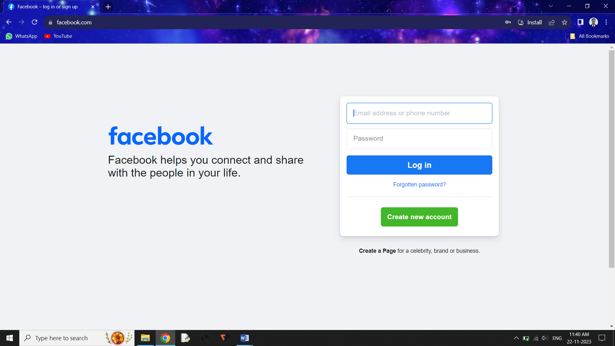

Fig-4.1 Facebook login Page.

**7**

**Chapter-5**

**Source Codes**

This is the Source code by which we can run the My Portfolio Website and the files which contains and links with this code for performing functions.

**5.1 CSS Files.**

**5.1.1 main.CSS**

@import url(//db.onlinewebfonts.com/c/0923ee644c97a87d70269aa80a6f1e79?family=The+Historia+Demo);

@font-face {font-family: "The Historia Demo"; src: url("//db.onlinewebfonts.com/t/0923ee644c97a87d70269aa80a6f1e79.eot"); src: url("//db.onlinewebfonts.com/t/0923ee644c97a87d70269aa80a6f1e79.eot?#iefix") format("embedded-opentype"), url("//db.onlinewebfonts.com/t/0923ee644c97a87d70269aa80a6f1e79.woff2") format("woff2"), url("//db.onlinewebfonts.com/t/0923ee644c97a87d70269aa80a6f1e79.woff") format("woff"), url("//db.onlinewebfonts.com/t/0923ee644c97a87d70269aa80a6f1e79.ttf") format("truetype"), url("//db.onlinewebfonts.com/t/0923ee644c97a87d70269aa80a6f1e79.svg#The Historia Demo") format("svg"); }

@import url(//db.onlinewebfonts.com/c/9a2bc11be56851dde98c1b49302cc21a?family=Gotham+Medium);

@font-face {font-family: "Gotham Medium"; src: url("//db.onlinewebfonts.com/t/9a2bc11be56851dde98c1b49302cc21a.eot"); src: url("//db.onlinewebfonts.com/t/9a2bc11be56851dde98c1b49302cc21a.eot?#iefix") format("embedded-opentype"), url("//db.onlinewebfonts.com/t/9a2bc11be56851dde98c1b49302cc21a.woff2") format("woff2"), url("//db.onlinewebfonts.com/t/9a2bc11be56851dde98c1b49302cc21a.woff") format("woff"), url("//db.onlinewebfonts.com/t/9a2bc11be56851dde98c1b49302cc21a.ttf") format("truetype"), url("//db.onlinewebfonts.com/t/9a2bc11be56851dde98c1b49302cc21a.svg#Gotham Medium") format("svg"); }/*Start global*/

*{

margin: 0;

padding: 0;

box-sizing: border-box;

}

html{

font-size: 10px;

font-family: 'Gotham Medium';

color: #c5c5c5;

}

**8**

body{

width: 100%;

height: 100%;

background: black no-repeat center fixed;

background-size: cover;

}

section{

padding: 6rem 0;

}

a{

text-decoration: none;

color:#2e89ff;

}

address {

display: block;

font-style: normal;

font-size: 1.8rem;

}

p{

font-family: 'Gotham Medium';

line-height: .6cm;

font-size: 1.8rem;

font-weight: 200;

}

img{

width: 100%;

}

/*End global*/

/*Start reusable*/

.container{

width: 90%;

max-width: 120rem;

height: 100%;

margin: 0 auto;

position: relative;

}

.section-heading{

text-align: center;

margin-bottom: 10rem;

}

**9**

.section-heading h1{

font-family: 'Dancing Script', cursive;

font-size: 4rem;

color: rgb(255, 255, 255);

font-weight: 400;

position: relative;

margin-bottom: 1.5rem

}

.section-heading h1::before,

.section-heading h1::after{

font-family: 'Dancing Script', cursive;

content: '';

position: absolute;

bottom: -.8rem;

left: 50%;

transform: translateX(-50%);

background-color: rgba(255, 255, 255, 0.842);

}

.section-heading h1::before{

width: 10rem;

height: 3px;

border-radius: .8rem;

}

.section-heading h1::after{

width: 1.5rem;

height: 1.5rem;

border-radius: 100%;

bottom: -1.3rem;

}

.section-heading h6{

margin-top: 1rem;

font-size: 2rem;

font-weight: 300;

color: rgb(160, 160, 160);

}

.has-margin-right{

margin-right: 5rem;

}

.has-margin-left{

margin-left: 5rem;

}

/*End reusable*/

**10**

/*Start header*/

header{

width: 100%;

height: 100vh;

}

.top-nav{

width: 100%;

height: 100vh;

position: fixed;

top: -100vh;

z-index: 50;

background-color: #1e1e35e8;

border-bottom-right-radius: 100%;

border-bottom-left-radius: 100%;

transition: all 650ms cubic-bezier(1,0,0,1);

}

.nav-list{

list-style: none;

width: 100%;

height: 100%;

display: flex;

justify-content: center;

align-items: center;

}

li{

margin: 0 2rem;

}

.nav-link{

font-family: 'Dancing Script', cursive;

font-size: 5rem;

padding: 1rem;

color: #eee;

text-decoration: none;

}

.nav-link:hover,

.nav-link:focus{

background: linear-gradient(#f0c800ce,#ff5a3dcb);

-webkit-background-clip: text;

-webkit-text-fill-color: transparent;

}

.top-nav.open{

top: 0;

**11**

border-radius: initial;

}

.menu-toggler{

position: absolute;

top: 5rem;

right: 5rem;

width: 5rem;

height: 4rem;

display: flex;

flex-direction: column;

justify-content: space-between;

cursor: pointer;

z-index: 1500;

transition: transform 850ms ease-out;}

.menu-toggler.open{

transform: rotate(-45deg);}

.bar{

background: rgb(207, 204, 204);

width: 100%;

height: 4px;

border-radius: .8rem;}

.bar.half{

width: 50%;}

.bar.start{

transform-origin: right;

transition: transform 650ms cubic-bezier(.54,-.81,.57,.57);}

.open .bar.start{

transform: rotate(-450deg) translateX(.8rem);

}

.bar.end{

align-self: flex-end;

transform-origin: left;

transition: transform 650ms cubic-bezier(.54,-.81,.57,.57);}

.open .bar.end{

transform: rotate(-450deg) translateX(-.8rem);

}

.landing-text{

position: absolute;

top: 50%;

left: 50%;

transform: translate(-50%, -50%);

width: 100%;

text-align: center;

z-index: 1;

**12**

}

.landing-text h1{

font-size: 20rem;

font-family: 'Brush Script MT', cursive;

background: linear-gradient(#f0c800ce,#ff5a3dcb);

-webkit-background-clip: text;

-webkit-text-fill-color: transparent;

padding: 1rem;

user-select: none;

}

.landing-text h6{

font-size: 2.5rem;

font-weight: 300;

}

.left-circ{

position: relative;

height: 75%;

width: 17%;

top: 10%;

animation:move2 4s infinite;

animation-delay: 0s;

}

.circle-img{

position: absolute;

width: 18%;

height: 11%;

right: 0%;

top: 30%;

animation:move 4s infinite;

animation-direction: initial;

}

.landing-text .scrolldown{

position: absolute;

bottom: -20rem;

left: 50%;

width: 40px;

height: 40px;

background-color: rgba(255, 255, 255, 0);

transform: translateY(-80px) translateX(-50%)

**13**

rotate(45deg);

}

.scrolldown span{

position: absolute;

top: 0;

left: 0;

display: block;

width: 100%;

height: 100%;

border-bottom: 2px solid #fff ;

border-right: 2px solid #fff ;

animation: animate 1.5s linear infinite;

opacity: 0;

}

.scrolldown span:nth-child(1){

transform: translate(-15px, -15px);

animation-delay: -0.4s;

}

.scrolldown span:nth-child(2){

transform: translate(0, 0);

animation-delay: -0.2s;

}

.scrolldown span:nth-child(3){

transform: translate(15px,15px);

animation-delay: 0s;

}

@keyframes animate{

0%{

top: -5px;

left: -5px;

opacity: 0;

}

25%{

top: 0px;

left: 0px;

opacity: 1;

}

50%, 100%{

top: 5px;

left: 5px;

opacity: 0;

}

}

/*End header*/

/*Start about*/

.about .container{ **14**

display: flex;

align-items: center;

justify-content: center;

}

.about-heading{

text-align: center;

text-transform: uppercase;

line-height: 0;

margin-bottom: 6rem;

}

.about-heading h1{

font-family: 'Dancing Script', cursive;

font-size: 10rem;

opacity: .3;

font-weight: 500;

}

.about-heading h6{

font-family: 'Dancing Script', cursive;

font-size: 2rem;

font-weight: 400;

}

.container{

position: relative;

}

.about-details h3{

font-size: 3rem;

font-weight: 400;

color: white;

}

.about-details a:hover{

color: #0059ff;

}

.profile-img{

flex: .8;

margin-right: 5rem;

}

.about-details{

flex: 1;

}

.social-media{

margin-top: 5rem;

}

**15**

.social-media i{

font-size: 5rem;

transition: color 650ms;

}

.fa-medium:hover{

color: #ffffff;

}

.fa-github-square:hover{

color: #ffffff;

}

.fa-linkedin:hover{

color: #ffffff ;

}

.fa-twitter-square:hover{

color: #ffffff ;

}

.fa-behance-square:hover{

color: #ffffff ;

}

.skills-img{

position: absolute;

width: 25%;

height: 15%;

top: 100%;

right: 0%;

animation:move2 4s infinite;

}

/*End about*/

/*Start services*/

.services-img{

position: absolute;

left:-10%;

top: 70rem;

height: 10%;

width: 15%;

animation:move2 4s infinite;

}

.my-skills{

border-top: 4px solid #ff5a3d;

**16**

position: relative;

margin-top: 15rem;

display: grid;

grid-template-columns: repeat(auto-fit, minmax(15rem,1fr));

grid-gap: 3rem;

text-align: left;

}

.skill{

display: flex;

flex-direction: column;

justify-content: left;

align-items: left;

}

.skill h3{

text-align: left;

color: #ffee00;

letter-spacing: 2px;

font-size: large;

margin: 2rem -2px 2rem 0;

}

.skill h1{

text-align: left;

letter-spacing: 2px;

margin: 2rem -2px 2rem 0;

}

.my-skills .skill{

border-right: none;

margin-right: 1rem;

padding-right: 1rem;

position: relative;

}

.my-skills .skill:last-of-type{

padding-bottom: 0;

margin-bottom: 0;

border: none;

}

.my-skills .skill::before,

.my-skills .skill::after{

position: absolute;

display: grid;

left: 0%;

transform: translateX(-50%);

}

**17**

.my-skills .skill::before{

content: attr(data-date);

top: -5rem;

text-align-last: auto;

text-align: right;

font-size: 1.5rem;

color: white;

margin-left: 5rem;

}

.my-skills .skill::after{

top: -1rem;

content: '';

box-shadow: 0 0 0 4px #ff5a3d;

border-radius: 100%;

height: 1.5rem;

width: 1.5rem;

background-color: #ffe838;

}

.my-skills a{

color:#ff961e;

font-size: 1.5rem;

text-decoration: underline;

}

.my-skills a:hover{

color:#c26700;

}

/*End services*/

/*Start portfolio*/

.portfolio-item{

display: flex;

align-items: center;

justify-content: center;

margin-bottom: 5rem;

}

.portfolio-item:last-child{

margin-bottom: 0;

}

.portfolio-img{

flex: .9;

}

.portfolio-description{

flex: 1;

font-size: 4rem;

}

**18**

.portfolio-description h1{

font-size: 3rem;

margin: 1rem 0;

font-weight: 400;

}

.portfolio-description h6{

font-size: 1.5rem;

text-transform: uppercase;

font-weight: 350;

opacity: .6;

margin-bottom: 0rem;

}

.portfolio-description .cta{

display: inline-block;

margin-top: 2.5rem;

font-size: 1.5rem;

text-transform: uppercase;

color: #2e89ff;

}

.portfolio-description .cta:hover{

color: #0059ff;

}

/*End services*/

/*Start timeline*/

.timeline ul{

border-left: 4px solid #ffe838;

border-radius: .8rem;

background-color: rgba(29, 29, 29, 0.616);

margin: 0 auto;

position: relative;

padding: 5rem;

list-style: none;

text-align: left;

width: 70%;

}

.timeline h1{

letter-spacing: 1px;

text-transform: uppercase;

font-weight: 400;

margin-bottom: 1rem;

color: #ffffff;

**19**}

.timeline .date{

border-bottom: 1px solid rgba(255, 255, 255, 0.281);

margin-bottom: 1rem;

padding-bottom: 1rem;

position: relative;

}

.timeline .date:last-of-type{

padding-bottom: 0;

margin-bottom: 0;

border: none;

}

.timeline .date::before,

.timeline .date::after{

position: absolute;

display: block;

top: 50%;

transform: translateY(-50%);

}

.timeline a{

text-decoration: underline;

color:#ffae17;

font-size: 1.5rem;

}

.timeline a:hover{

color: #cf8906;

}

.timeline .date::before{

content: attr(data-date);

left: -25rem;

text-align: right;

min-width: 12rem;

font-size: 1.5rem;

color: white;

width: 8rem;

text-align: center;

}

.timeline .date::after{

content: '';

box-shadow: 0 0 0 4px #ffe838;

border-radius: 100%;

left: -8rem;

**20**

height: 1.5rem;

width: 1.5rem;

background-color: #313534;

}

.experience-img{

position: absolute;

height: 50%;

width: 20%;

right: 0%;

animation:move 4s infinite;

}

.contact-img{

position: relative;

left: -10%;

width: 15%;

height: 15%;

animation:move2 4s infinite;

}

/*End timeline*/

/*Start contact*/

/*End contact*/

/*Start footer*/

.copyright{

width: 100%;

text-align: center;

vertical-align: middle;

background-color: #ffffff;

padding: 1rem 0;

position: relative;

}

.up{

position: absolute;

width: 5rem;

height: 5rem;

border: 1px white solid;

background-color: #000000de;

top: -2.5rem;

right: 5rem;

border-radius: 100%;

display: flex;

animation: pulse 2s infinite;

cursor: pointer;

}

**21**

.up i{

color: #ffffff;

font-size: 2rem;

margin: auto;

}

.copyright p{

font-size: 1.5rem;

color: black;

font-weight: 600;

font-family: 'Gotham Medium';

}

/*End footer*/

/*Start animations*/

@keyframes move{

0% {

transform: scale(0.95);

box-shadow: 0 0 0 0 rgba(0, 0, 0, 0.7);

}

70% {

transform: scale(1);

box-shadow: 0 0 0 10px rgba(0, 0, 0, 0);

}

100% {

transform: scale(0.95);

box-shadow: 0 0 0 0 rgba(0, 0, 0, 0);

}

}

@keyframes move1{

0% {

transform: scale(1.05);

box-shadow: 0 0 0 0 rgba(0, 0, 0, 0.7);

}

70% {

transform: scale(1);

box-shadow: 10 0 0 0px rgba(0, 0, 0, 0);

}

100% {

transform: scale(1.05);

box-shadow: 0 0 0 0 rgba(0, 0, 0, 0);

}

**22**

}

@keyframes move2{

100% {

transform: scale(1.15);

box-shadow: 0 0 0 0 rgba(0, 0, 0, 0);

}

70% {

transform: scale(1);

box-shadow: 10 0 0 0px rgba(0, 0, 0, 0);

}

0% {

transform: scale(1.15);

box-shadow: 0 0 0 0 rgba(0, 0, 0, 0.7);

}

}

@keyframes pulse{

0%{

box-shadow: 0 0 0 0 rgba(253,87,191,.99);

}

70%{

box-shadow: 0 0 0 0 rgba(253,87,191,0);

}

100%{

box-shadow: 0 0 0 0 rgba(253,87,191,0);

}

}

/*End animations*/

/*Start media queries*/

@media screen and (max-width: 768px){

body{

width: 100%;

height: 100%;

background: black no-repeat center fixed;

background-size: cover;

}

p{

font-size: small;

}

.section-heading h1::after{

width: 1.3rem;

height: 1.3rem;

border-radius: 100%;

}

**23**

.landing-text h1{

font-size: 15rem;

}

.landing-text h6{

font-size: 1.7rem;

}

.nav-list{

flex-direction: column;

}

li{

margin: 2rem 0;

}

.nav-link{

font-size: 4.5rem;

}

.circle-img{

width: 25%;

height: 40%;

top: 50rem;

}

.profile-img{

flex: 1;

}

.about-heading h1{

font-size: 8rem;

}

.section-heading h1{

font-size: 3rem;

}

.about-details h3{

font-size: 2rem;

font-weight: 400;

color: white;

}

.about-details .nav-list{

flex-direction: initial;

}

.about-details li{

margin: 0 2rem;}

**24**

.skills-img{

top: 50rem;

}

.services-img{

top: 100rem;

}

.my-skills{

border-top: 4px solid #ff5a3d;

position: relative;

margin-top: 10rem;

display: grid;

margin-left: 3rem;

grid-template-columns: repeat(auto-fit, minmax(13rem,1fr));

grid-gap: 1rem;

text-align: left;

}

.skill{

display: flex;

flex-direction: column;

justify-content: left;

align-items: left;

}

.skill h3{

text-align: left;

color: #ffee00;

letter-spacing: 2px;

font-size: medium;

margin: 2rem -2px 2rem 0;

}

.skill h1{

text-align: left;

letter-spacing: 1px;

margin: 2rem -2px 2rem 0;

}

.my-skills .skill{

border-right: none;

margin-right: 0rem;

padding-right: 0rem;

position: relative;

}

.my-skills .skill:last-of-type{

**25**

padding-bottom: 0;

margin-bottom: 0;

border: none;

}

.my-skills .skill::before,

.my-skills .skill::after{

position: absolute;

display: grid;

left: 0%;

transform: translateX(-50%);

}

.my-skills a{

color:#ff961e;

font-size: 1.5rem;

text-decoration: underline;

}

.my-skills a:hover{

color:#c26700;

}

.my-skills .skill::before{

content: attr(data-date);

top: -5rem;

text-align-last: auto;

text-align: right;

min-width: 12rem;

font-size: 1.5rem;

color: white;

text-align: center;

margin-left: 2rem;

}

.my-skills .skill::after{

top: -1rem;

content: '';

box-shadow: 0 0 0 4px #ff5a3d;

border-radius: 100%;

height: 1.5rem;

width: 1.5rem;

background-color: #ffe838;

}

.icon-container{

width: 7rem;

height: 7rem;

}

.icon-container i{

**26**

font-size: 4rem;

}

.timeline ul{

margin: 0 0 0 auto;

}

.timeline .date::before{

left: -20rem;

}

.timeline .date::before{

font-size: 1.3rem;

padding-left: 1rem;

width: 5rem;

text-align: center;

}

.timeline .date::after{

left: -5.9rem;

}

.timeline .date{

border-bottom: 1px solid rgba(255, 255, 255, 0.281);

margin-bottom: 1rem;

font-size: 1rem;

padding-bottom: 1rem;

position: relative;

}

}

@media screen and (max-width: 600px){

.menu-toggler{

top: 2rem;

right: 2rem;

}

p{

font-size: small;

}

.landing-text .scrolldown{

width: 30px;

height: 30px;

}

.landing-text h1{

font-size: 8rem;

}

.landing-text h6{

**27**

font-size: 1.4rem;

}

.nav-link{

font-size: 3.5rem;

}

.about-heading h1{

font-size: 7rem;

}

.about-details h3{

font-size: 2rem;

font-weight: 300;

color: white;

}

.about .container{

display: list-item;

}

.circle-img{

width: 30%;

height: 45%;

top: 60rem;

}

.left-circ{

width: 30%;

height: 70%;

top: 5%

}

.services-img{

width: 22%;

height: 15%;

top: 110rem;

}

.profile-img{

top: -10%;

margin: 0 0 7rem 0;

}

.skills-img{

top: 100%;

}

.my-skills{

border-left: 4px solid #ff5a3d;

border-top: none;

position: relative;

align-items: center;

**28**

display: grid;

margin: 13rem;

grid-template-columns: repeat(auto-fit, minmax(25rem,1fr));

grid-gap: 2.5rem;

text-align: left;

}

.skill{

display: flex;

flex-direction: column;

justify-content: left;

align-items: left;

}

.skill h3{

text-align: left;

color: #ffee00;

letter-spacing: 2px;

font-size: 1.8rem;

margin: -1.5rem 1px 1rem 2rem;

}

.my-skills .skill{

border-right: none;

margin-right: 1rem;

padding-right: 1rem;

position: relative;

}

.my-skills .skill:last-of-type{

padding-bottom: 0;

margin-bottom: 0;

border: none;

}

.my-skills p{

margin-left: 2rem;

font-size: 1.5rem;

}

.my-skills .skill::before,

.my-skills .skill::after{

position: absolute;

display: grid;

left: 0%;

transform: translateX(-50%);

}

.my-skills .skill::before{

content: attr(data-date);

left: -9rem;

**29**

width: 10rem;

top: -1rem;

text-align-last: auto;

min-width: 10rem;

font-size: 1.5rem;

color: white;

text-align: center;

}

.my-skills .skill::after{

top: -1rem;

content: '';

box-shadow: 0 0 0 4px #ff5a3d;

border-radius: 100%;

height: 1.5rem;

width: 1.5rem;

background-color: #ffe838;

}

.my-skills a{

color:#ff961e;

font-size: 1.3rem;

margin-left: 2rem;

margin-bottom: 2rem;

}

.my-skills a:hover{

color:#c26700;

}

.portfolio-item{

flex-direction: column;

}

.portfolio-description{

flex: 1;

font-size: 1.5rem;

}

.portfolio-description h1{

font-size: 2rem;

margin: 1rem 0rem;

font-weight: 400;

}

.portfolio-description h6{

font-size: 1.5rem;

text-transform: uppercase;

font-weight: 300;

opacity: .6;

**30**

font-family: 'Gotham Medium';

}

.portfolio-description .cta{

display: inline-block;

margin-top: 2.5rem;

font-size: 1.5rem;

text-transform: uppercase;

color: #2e89ff;

}

.portfolio-img{

margin: 0 0 2rem 0;

}

.portfolio-description{

margin: 0;

order: 2;

}

.timeline p{

font-size: 1.3rem;

line-height: .5cm;

}

.timeline .date::before{

font-size: 1.3rem;

left: -18rem;

width: 5rem;

min-width: 10rem;

text-align: center;

}

.timeline h1{

font-size: 1.5rem;

text-transform: uppercase;

font-weight: 300;

margin-bottom: 1rem;

color: #ffffff;

}

.experience-img{

width: 25%;

height: 25%;

}

**31**

.up{

right: 2rem;

}

.social-media{

margin-top: 5rem;

}

.social-media i{

font-size: 4.5rem;

transition: color 650ms;

}

address {

display: block;

font-style: normal;

font-size: 1.5rem;

}

}

/*End media queries*/

* 1. **HTML File.**
     1. **My Portfolio Website.html**

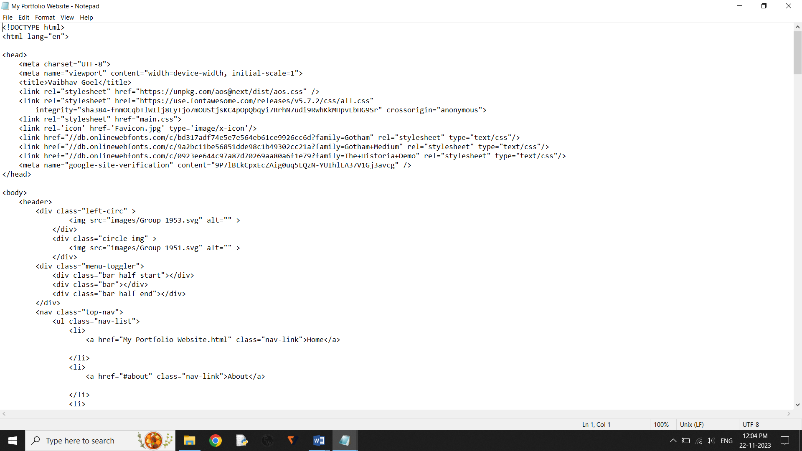

**32**

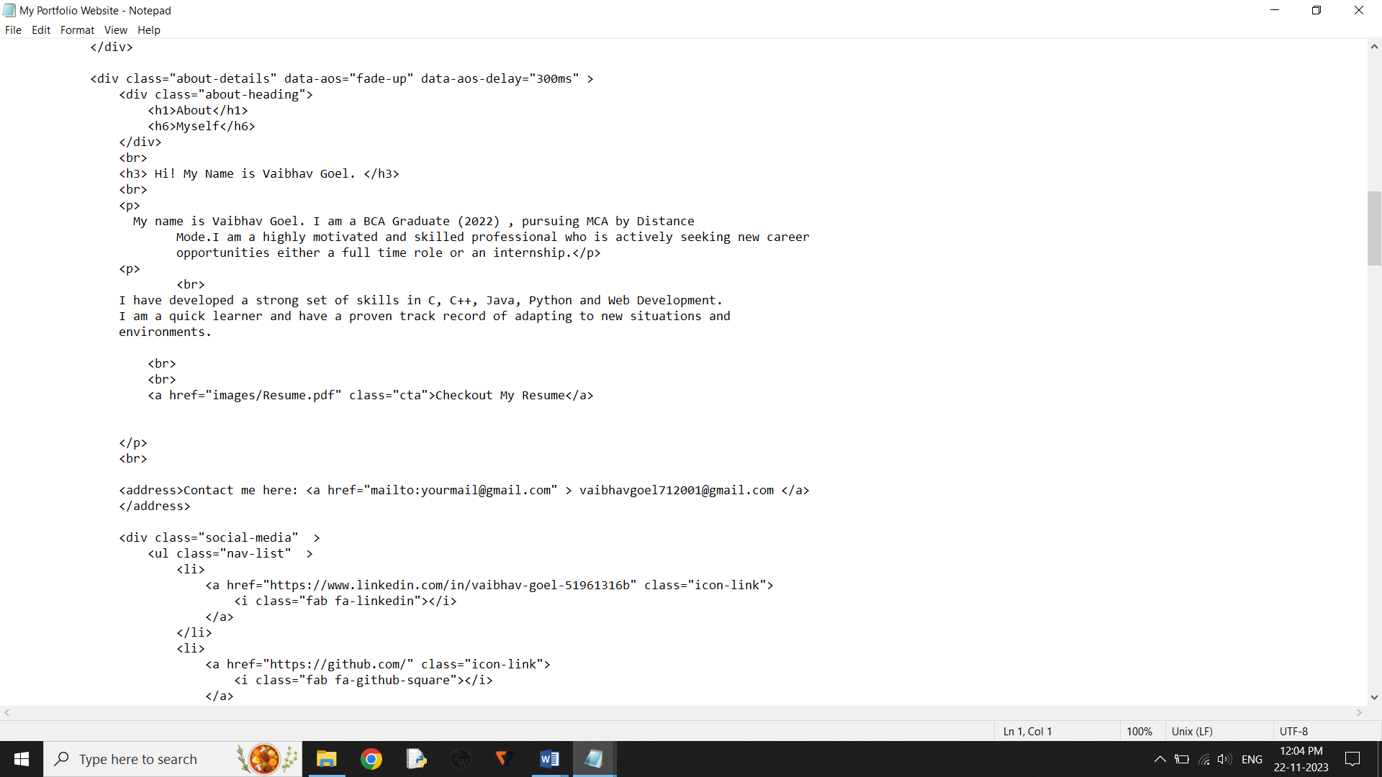

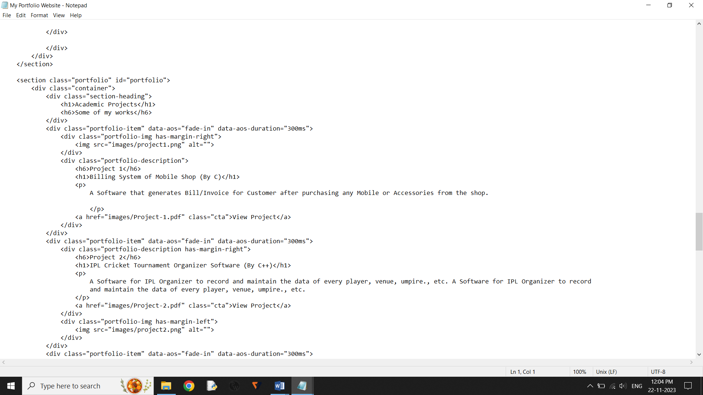

Fig-5.1 Screenshots HTML File Code.

**33**

**Chapter-6**

**Conclusion**

We can conclude that this software can only be used by me and I have only access to add, delete, modify or update the data of projects, details, and many more.

The main limitation of this software is that unregistered user cannot access to this software to add, delete, modify or update the data of projects, details, and many more.

Owner (I) have the only right to do the functions mentioned on portfolio.

#### 34

**The End**